EXCHANGE / RETURN FORM 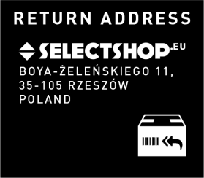
ORDER NO
SURNAME
FIRST NAME
STREET / NO.
POSTCODE / DOMICILE
PHONE NO.
EMAIL ADDRESS
EXCHANGE / REFUND
If the item/s ordered do not meet your expectations, and the return is made within the return period, then an exchange or refund can be carried out without any problems. For further information, please visit the Customer Service section of our website.

Would you like another item - as quick as possible? Simply make a new order through our online shop.
The monetary value of the returned goods will be subtracted from your new order, no matter if it‘s an exchange or refund.
For advanced or cash payments, we would need your bank details for the reimbursement transaction:
ACCOUNT HOLDER
IBAN
BIC

*Select the correct ittem
* FILL IN CASE OF PRODUCT EXCHANGE
Number of return order
Returned product
Number of the new order
New order product
* RETURNS
Article no. | Description | Colour | Size | Quantity | Reason*
*01 Too big / too loose, 02 Too small / too tight, 03 I don‘t like the product, 04 The product is diff erent to its picture, 05 Delivery was too late, 06 Delivery was incorrect,
07 Damaged/faulty products

FURTHER QUESTIONS?
Please contact our Customer Service.
Tel.: +48 531 681 467
E-Mail: info@selectshop.eu

You have the right to withdraw from this contract within 30 days without giving any reason. The withdrawal period will expire after30 days from the day on which you received the order. To exercise the right of withdrawal, you must inform us of your decision to withdraw from this contract by an unequivocal statement. You may use above withdrawal form or print out the template.To meet the withdrawal deadline, it is sufficient for you to send your statement concerning your exercise of the right of withdrawal before the withdrawal period has expired (within 30 days from the day on which you received the order). We will carry out such reimbursement using the same means of payment as you used for the initial transaction. You will not cover any additional costs concerning that return.

